Analysis Report on Pymaceuticals

**Introduction**

Pymaceuticals specializes in drug-based, anti-cancer pharmaceuticals (e.g. skin cancer). In the most recent animal study, 250 mice were treated through a variety of drug regime over the course of 45 days, screening for 10 potential treatments.

Along with the study, two datasets were generated: mouse_drug_data.csv and clinicaltrial_data.csv.

All the analysis is based on the study data and focuses on comparing how four treatments: Capomulin, Infubino, Ketapril, and Placebo.

This report is going to introduce the strategies which have been used to determine the data. Then it presents some key findings based on analyzing the provided data. It will use relevant graphs to help demonstrate what the data tell. It would be extremely valuable for future project investment and management.

**Strategies & Methods**

1. **First task is to review the two original datasets:**

M[ouse_drug_data.csv](http://localhost:8888/edit/data/mouse_drug_data.csv) tells, each of 250 mice were given a unique ID and treated with one of ten types of drugs.

clinicaltrial_data.csv has 1893 sets of data on Mouse, Timepoint, Tumor Volume, and Metastatic Site.

Both of the two datasets are completed, no data missing or inapplicable.

1. **Second task is to select samples:**

The objective of the analysis is to compare effects of four treatments: Capomulin, Infubinol, Ketapril, and Placebo. Therefore, the function of df.drop(rows) was applied to mouse_drug_data.

1. **Third task is to connect the two datasets:**

It can be noticed that ‘Mouse ID’ connects the two datasets which don’t seem related.

Accordingly, the function of pd.merge() was applied to the two datasets to form a new and expansive dataframe for the following analysis. ‘Mouse ID’ was the key.

1. **Fourth task is to see how the study worked**

In order to uncover the treatments performance, a series of tables and graphs were produced to present the study results, using plt.errorbar, df.plot, etc.

**Three Important Observations**

**The first finding** is that during the whole period of experiment, tumor volume reduced only after the mice received Capomulin Treatment. It happened continuously from 45 mm3 to 36mm3. By contrast, the effects of the other three drugs (Infubinol, Ketapril, and Placebo) were extraordinarily identical and the tumor volume constantly increased from 45mm3 to around 68mm3. The results is showed in the Graph “Tumor Response to Treatment” presents.

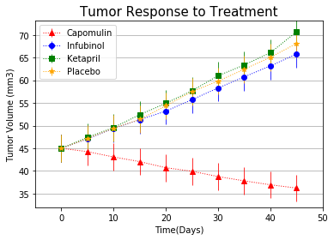

**The second finding** is that after 45 day treatment on 4 groups of 25 mice, 21 mice survived after they received Capomulin treatment. It means only 4 mice in this group died. The rest three treatments only worked on 9, 11, and 11 mice in their groups. These results can be found in Table “ The Amount of Survival Mice” .

**Table: The Amount of Survival Mice**

|  |  |  |  |  |
| --- | --- | --- | --- | --- |
| Timepoint | Capomulin | Infubinol | Ketapril | Placebo |
| 0 | 25 | 25 | 25 | 25 |
| 5 | 25 | 25 | 23 | 24 |
| 10 | 25 | 21 | 22 | 24 |
| 15 | 24 | 21 | 19 | 20 |
| 20 | 23 | 20 | 19 | 19 |
| 25 | 22 | 18 | 19 | 17 |
| 30 | 22 | 17 | 18 | 15 |
| 35 | 22 | 12 | 17 | 14 |
| 40 | 21 | 10 | 15 | 12 |
| 45 | 21 | 9 | 11 | 11 |

Furthermore, Graph “Survival Rate During Treatment” shows the mice survival rates. The Mice treated with Capomulin had the highest survival rate over 85% over the treatment course.

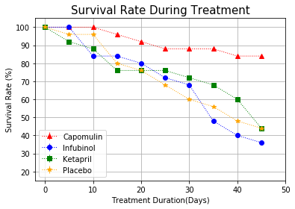

**The third finding** is that the drug treatment of Capomulin brought down 19% tumor volume. After receiving Infubinol drugs, the mice’s tumor volume increased 46% . Ketapril and Placebo treatments didn’t stop the tumor volume increasing up to 57% and 51% individually. Graph “Tumor Change Over 45 Day Treatment” shows the results.

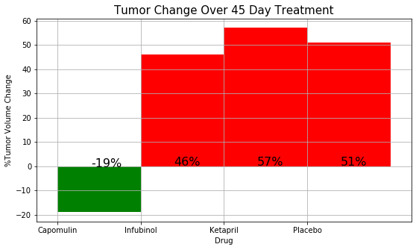

Combining the above findings, it obviously comes to a conclusion that the drug Capomulin performed positively during the 45 day treatment on 250 mice. Unfortunately, the other three drugs didn’t affect the same, conversely, they made the mice’s cancer condition worse.

However, the four drug treatment made significant contributions to the study in different perspectives. This would be extremely valuable for further studies.